Title: Regionwide 28: Quantifying Carryover Effects of Increasing Rates of Phosphorous Addition on Subsequent Rotation Productivity
Author: Timothy Albaugh, Jacob Bost, Matthew Sumnall, and Rachel Cook.
New or Updated: Updated
Species: Pine
RW Studies Used: All current RW28s
-----------------------------------------------------------------------------------------------------------------

Introduction
Phosphorus (P) fertilization at time of planting results in a Type A response throughout the rotation on P limited sites. When P and nitrogen are applied together on nutrient limited mid-rotation stands, a synergistic growth response is observed compared to when either element is applied alone. Consequently, cumulative P applications during a rotation may be more than 50 lbs ac-1 elemental phosphorus. If sufficient P has been applied in one rotation, additional P may not be necessary for the first few years in a subsequent rotation on the same site (Everett and Palm-Leis, 2009). Delaying the application of additional P would be beneficial biologically (only applying what the trees need when they need it), reduce the likelihood of off site movement of the added P, and reduce the length of time costs associated with the P application need to be carried in the rotation. Across a range in sites, a robust quantification of P availability from one rotation to the next (carry over) and associated growth responses would greatly benefit forest managers.

Study Objectives
The Regionwide 28 examines if there is P carryover and, if so, how long does it last. The study also examines if current rotation growth response is related to the amount of P applied in the previous rotation. The following hypotheses will be examined:
- Response duration and magnitude is positively related to previous rotation P.
- Response duration and magnitude is positively related to soil P concentration and content at time of planting.
- Soils with high clay content, low concentrations of aluminum and iron oxides, and a pH=>5 have more bioavailable P and a greater duration and magnitude of response.
- Response duration and magnitude is positively related to forest floor decomposition and P mineralization.

Experimental design
The study utilizes sites where a known amount of P was added in the previous rotation. The RW18 sites and the SouthEast Tree Research and Education Site (SETRES) meet this criteria and are being used as sites in the RW28. RW28 treatments group the prior study treatments by the amount of P applied in the previous rotation. In the RW28 each member of the group receives either additional P or no additional P at planting in the current rotation. All RW28 plots (except for the controls) receive 46 lbs ac⁻¹ nitrogen, 24 lbs ac⁻¹ potassium and a micronutrient mix to ensure that other nutrients are not limiting. Control plots will continue as true controls (no additions). Weed control will be applied in all treatment plots to eliminate all competing vegetation.

Current Status
Ten studies have been installed across a range of soil type (Table 1). There are an additional six RW18 sites that could be included in the RW28 but they have not been harvested. The oldest studies have completed six growing seasons. Given that we are still seeing treatment separation (see Results section), the study length has been extended from 6 years to 12 years. Additionally, we have adjusted the sample collection schedule (LINK to RW28 protocol).
Table 1: Installed RW28 studies
Study | Installed | Location | SPOT Code | Texture | Depth to clay | Drainage
282401 | 20191208 | Nassau, FL | A3PeaoPaAF | Clayey | 10-20 in | Poorly
284201 | 20200114 | Brantley, GA | D3PoioAlAF | Spodic | 10-20 in | Poorly
281303 | 20210209 | Scotland, NC | G4DeioLeSH | Sandy | 20-40 in | Somewhat excessively
282201 | 20220207 | Wilkes, GA | B2WokoGgPD | Fine Loamy | 5-10 in | Well
280601 | 20230221 | Brunswick, VA | B3WgkoGgPD | Fine Loamy | 10-20 in | Well
284501 | 20230412 | Marengo, AL | B2WeaoBbBP | Fine Loamy | 5-10 in | Well
284401 | 20240404 | Bradley, AR | E4PyioAvWG | Silty | 20-40 in | Poorly
281502 | 20240516 | Floyd, GA | C2WyxuLmMT | Coarse Loamy | 5-10 in | Well
284801 | 20250508 | Buna, TX | B3PyaoLbGF | Fine Loamy | 10-20 in | Poorly
285302 | 20250430 | Cross City, FL | F5PeaoLmGF | Deep subsoil | 40-80 in | Poorly

Results
Phosphorous carryover was observed at several sites where growth of treatments that received P only in the previous rotation equaled that of those treatments that received additional P in the current rotation. For example, at 281303, treatment 150 did not receive any P in the current rotation but grew at about the same rate at least through age 3 as treatment 151 which received P in the current rotation (Figure 1a). However, on this dry sandy site, there may be some separation between these two treatments beginning at age 4. Treatment 152 at 281303 which received much less overall P (only 45 kg ha⁻¹ and all in this rotation) compared to the other treatments experienced a large drop off in growth compared to the 150 and 151 treatments at age 4. It is not clear that this drop in growth is evidence of a P limitation or if other nutrients are limited at this site. At 284201, treatment differentiation was observed beginning at age 4 with one of the treatments that received P in the current rotation (80-45) growing better than the matched treatment (80-0) that did not receive P in the current rotation (Figure 2a). The 80-45 treatment was growing as well as 107-45 which also received P in the current rotation. At the same time, the 60-0 treatment which did not receive P in the current rotation and had received less P in the previous rotation was also growing as well as the 80-45 and 107-45 treatments. 284201 is a poorly drained site and we are currently examining if differences in elevation across the site may have improved the drainage for 60-0 such that it could grow as well as the best treatment that received P in the current rotation.
Foliar and soil phosphorous concentrations have been used to identify P limitations in previous studies. With the current data, it is not clear that these metrics will be useful for this purpose in this study (Figures 1b, 1c, 2b, and 2c), however, this is still being examined.
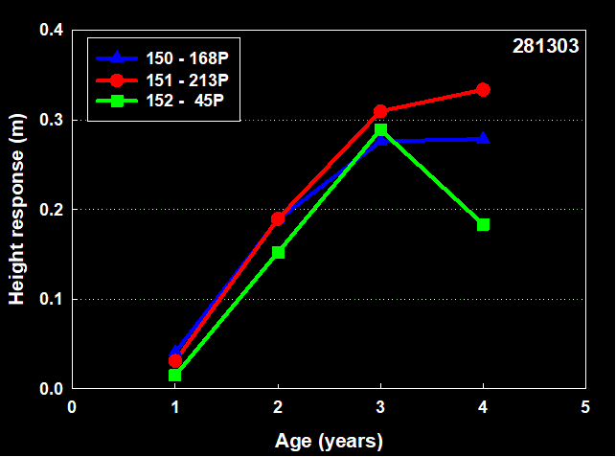 | 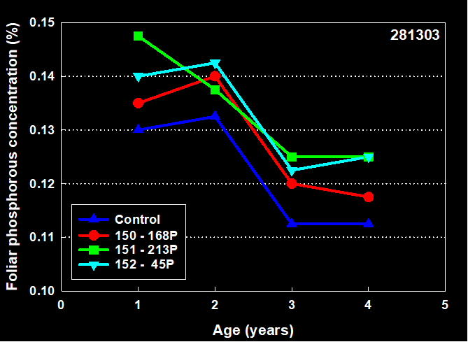
Figure 1a: 281303 height response for the three treatments: 45P ( which received no P in the previous rotation and 45 kg/ha⁻¹ P in the current rotation), 168P ( which received 168 kg/ha⁻¹ P in the previous rotation and none in the current rotation) and 213P ( which received 168 kg/ha⁻¹ P in the previous rotation and 45 in the current rotation ). | Figure 1b: 281303 foliar P concentrations for the treatments corresponding to the growth data in Figure 1a. | Figure 1c: 281303 surface soil P concentrations for the treatments corresponding to the growth data in Figure 1a.

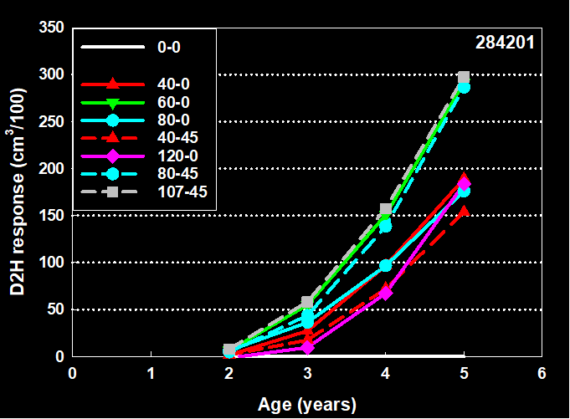 | 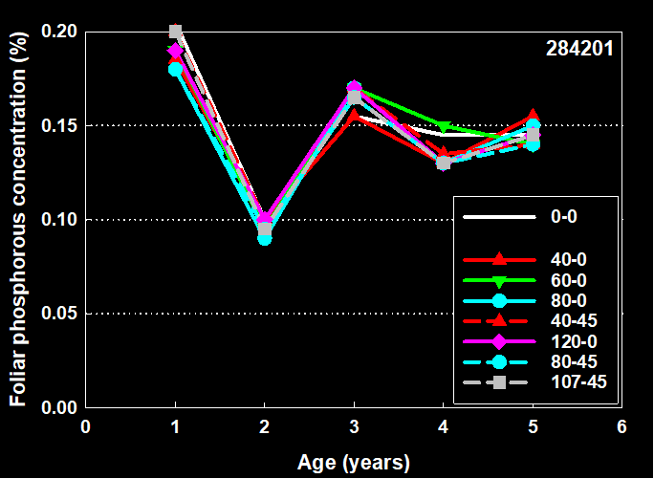
Figure 2a: 284201 stem volume (D²H) response for the eight treatments at the site where the first value for the treatment is the kg ha⁻¹ of P applied in the previous rotation and the second number is the kg ha⁻¹ of P applied in the current rotation. | Figure 2b: 284201 foliar P concentrations for the treatments corresponding to the growth data in Figure 2a. | Figure 2c: 284201 surface soil P concentrations for the treatments corresponding to the growth data in Figure 2a.

Conclusions or Future Direction
Clearly, P carryover has been observed. Work is ongoing to determine how these responses vary by sites and amount of applied P. We plan to install additional studies and continue to monitor all the current installations.

Additional Resources
Everett and Palm-Leis, 2009. Availability of residual phosphorus fertilizer for loblolly pine. Forest Ecology and Management 258: 2207-2213.

